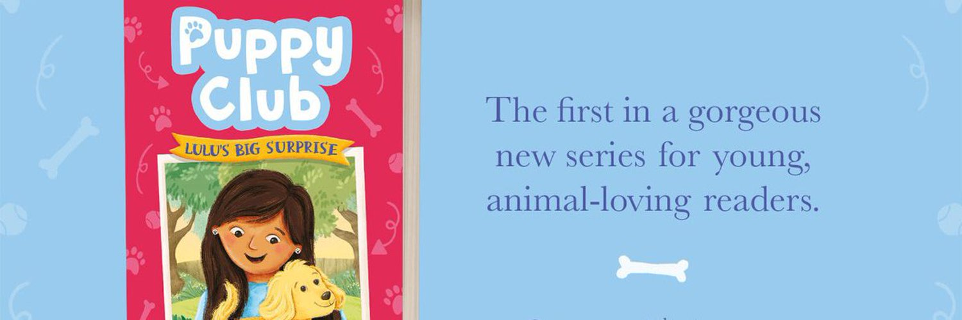
Hello!

I’ve always loved telling stories, ever since I was at primary school. I still have to pinch myself when I remember I’m an actual published author!

When I go into schools, children always ask me what inspired me to write my books. I write stories to entertain my own three children.

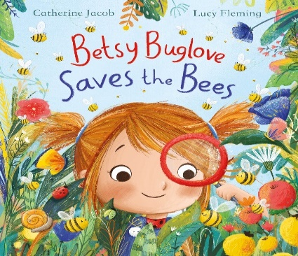
Take Betsy Buglove. She is based on my daughter who was five-years-old when I wrote my first Betsy story and is a real nature lover, never happier than when searching under rocks for woodlice, or saving stranded bees from being squashed under foot. It took another five years for Betsy Buglove Saves the Bees, exquisitely illustrated by Lucy Fleming, to be published but I’m delighted it is now in eleven different countries with more Betsy adventures soon!

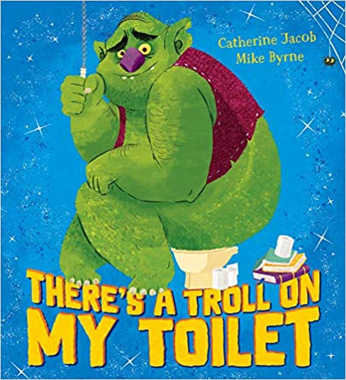
There’s a Troll on my Toilet, with hilarious illustrations by Mike Byrne, was another rhyming story I wrote for my pre-schoolers who LOVED anything spooky and funny. It was originally called There’s a Witch in my Kitchen but the publishers loved Troll so much, they decided to put him on the cover. I love reading this book to children as it is guaranteed to make them laugh.

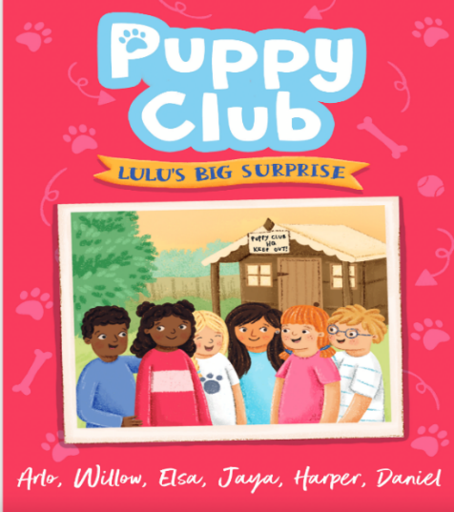
My new series, Puppy Club, beautifully illustrated by Rachael Saunders, is full of mischievous puppies, many based on our own Labradoodle. Do look out for it if you’re moving on from early readers to chapter books and love stories about animals and friendship.

There are so many wonderful books out there aren’t there? Some are funny, some are sad. Others are magical or mysterious and full of fantastical creatures and lands. Some books take you to far-flung places, while others look inside a character’s mind. Still others tell stories that might remind you of your own life. Sometimes it’s difficult to choose, but that’s all part of the adventure.

Happy adventuring!

Catherine J.

